**663565 NJERU OLIVER NJIRU**



## APT1050A: Lab Assignment#5 – java Database Connectivity with mysql

Summer 2022:

### *Instructor: Gerald Chege, PhD (*[*gchege@usiu.ac.ke)*](mailto:gchege@usiu.ac.ke;)

**_______________________________________________________________________**

Two Tier Systems Solution: Connecting back-end and Business Logic/User Interface

Section 1 – Database Backend Tier

1) Create a simple database using MySQL platform

* You need to start xampp located in c:\xampp
* Then run http:\\localhost
* Look for MySQL from the admin window

2) Create a table with relevant fields

Example:

database name: myUSIUdb

Table Name Student:

Student fields:

* studentID - datatype Varchar; size-10;
* FName - datatype Varchar; size-15;
* LName - datatype Varchar; size-15;
* Major - datatype Varchar; size-15;

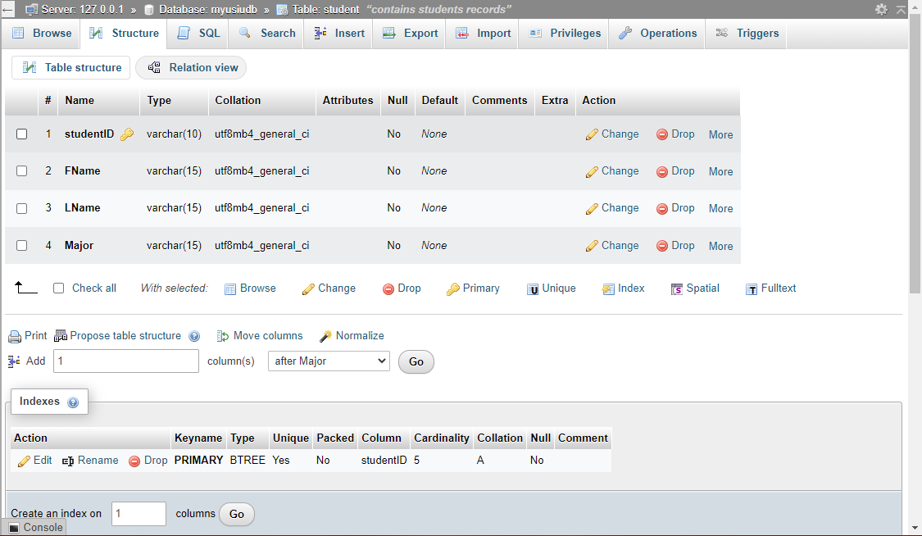

3) Enter sample data into table Student with about 10 records

Section 2: Business/Application Logic Tier

1) You need to download and install Netbeans Java Applications Development IDE into your computer. You can get Netbeans 8.2 from the USIU server using vpn. See instructions on blackboard using our usual Labs & Assignments Link.

Using the NetBeans IDE platform write a Java program to retrieve the back end student data you created above and display.

2) Include the MySQL library in your application – this contains the classes needed to connect your application to MySQL *(see Section 1 above).*

3) You can access databases from the Services tab in NetBeans IDE

4) See the example Lab in the provided Lab#5 package - Lab Example#1

* See also the provided user guide on how to work with mySQL & Java
* Lab Example#1 displays the data retrieved from your DB in a console.
* Details of how the Java program works will be explained in class, including how to create the DB driver connection string;

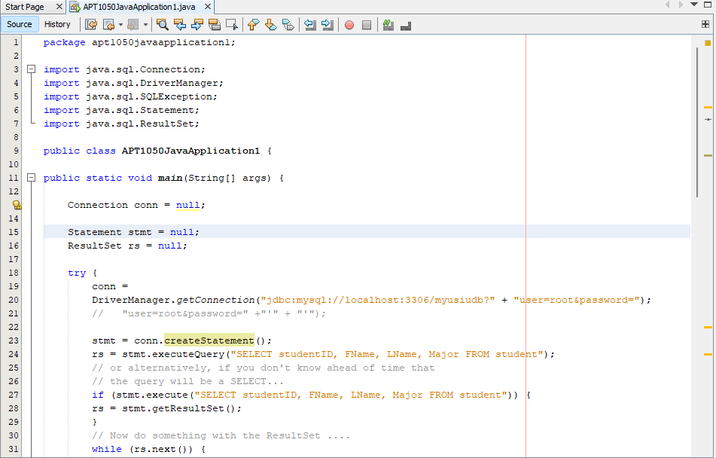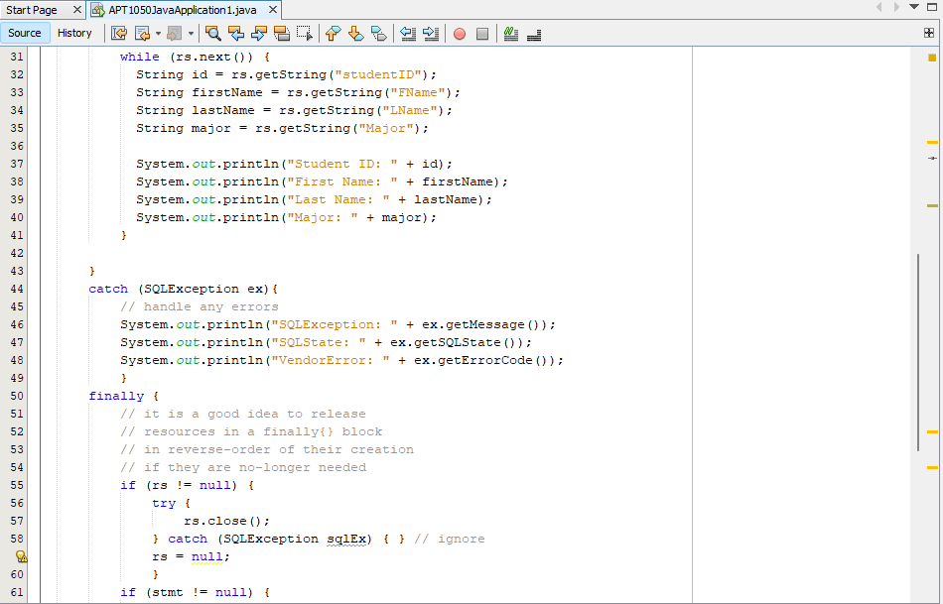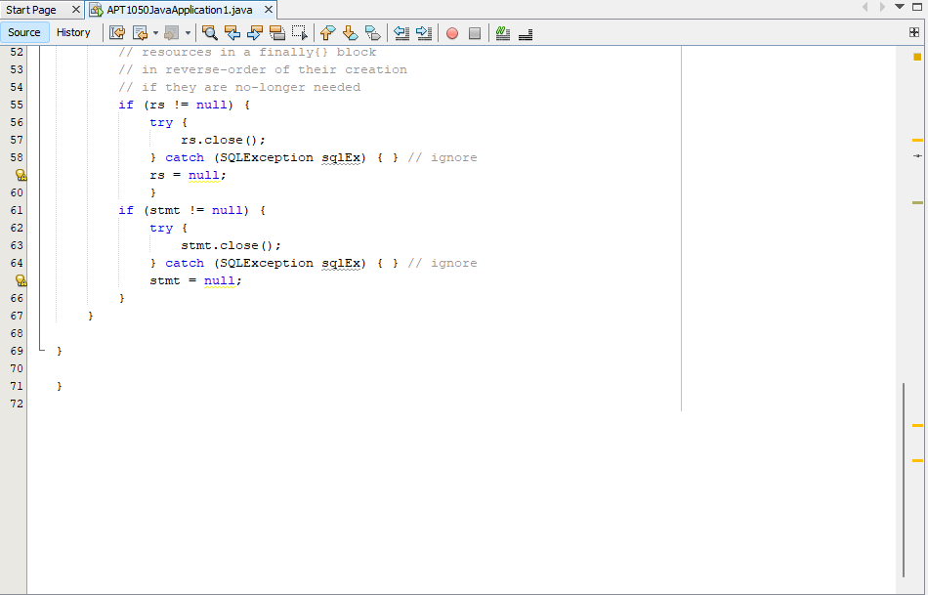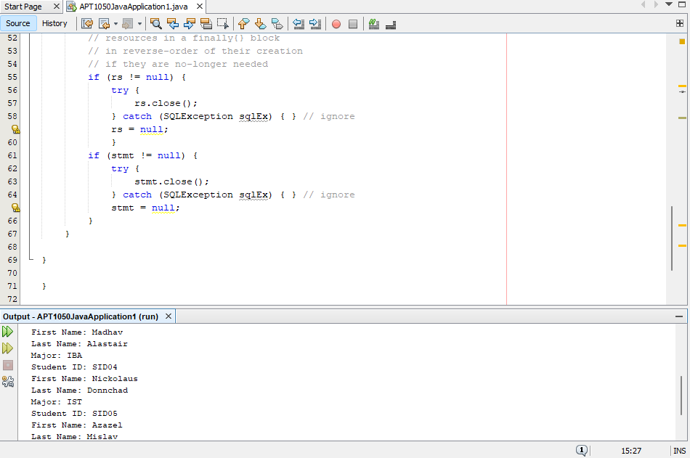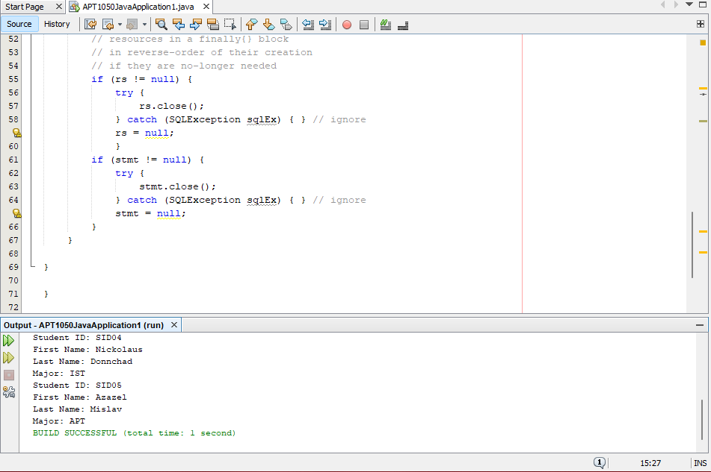

5) Write another program to display the student data in a nice GUI – Lab Example#2 – see same package;

* Lab Example#2 displays the data retrieved from your DB in a GUI interface.

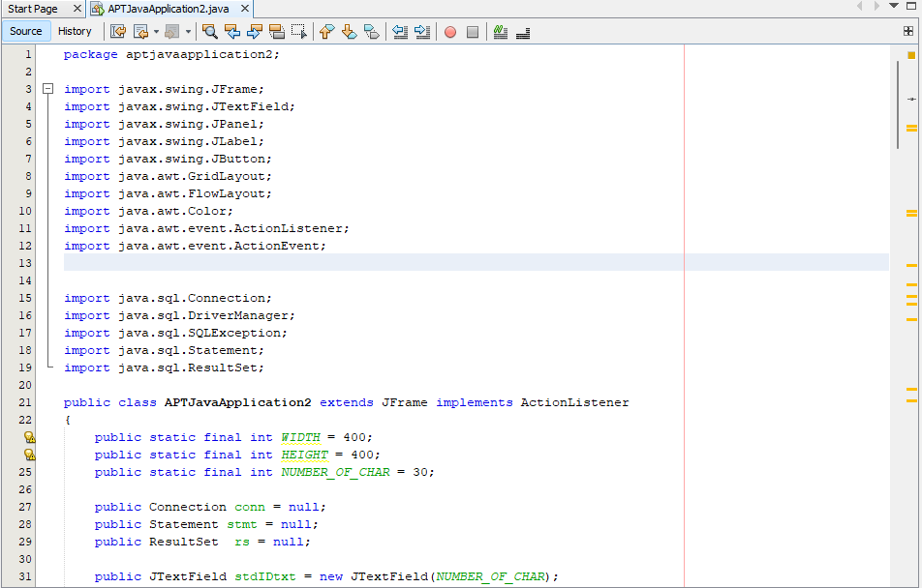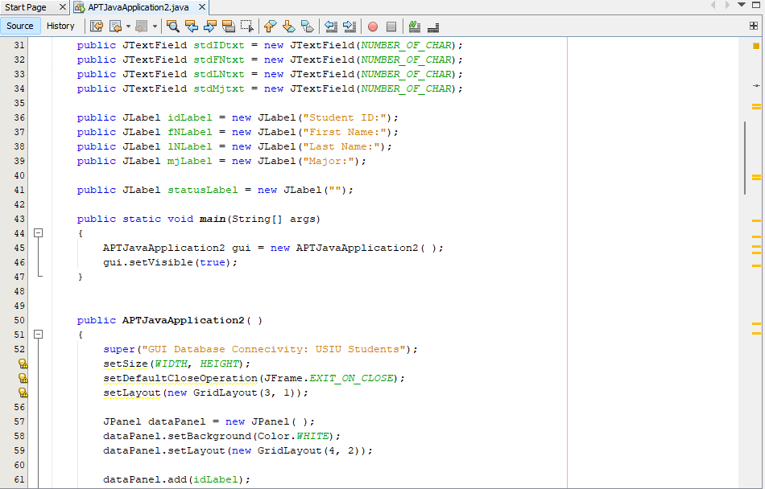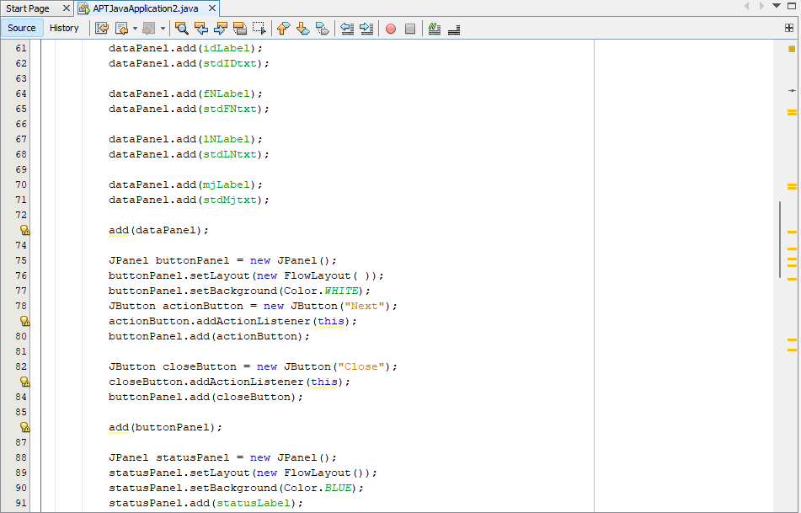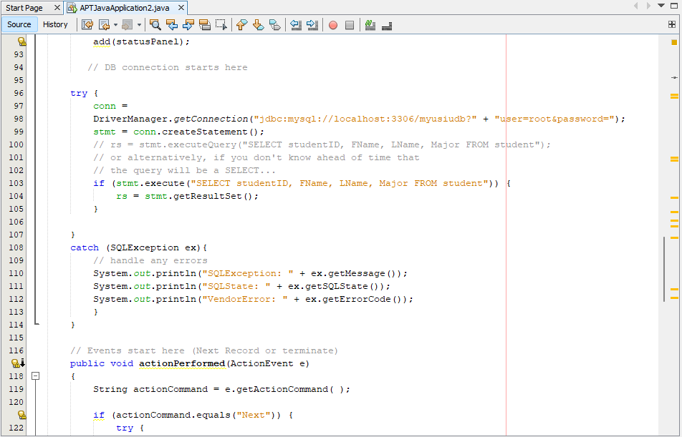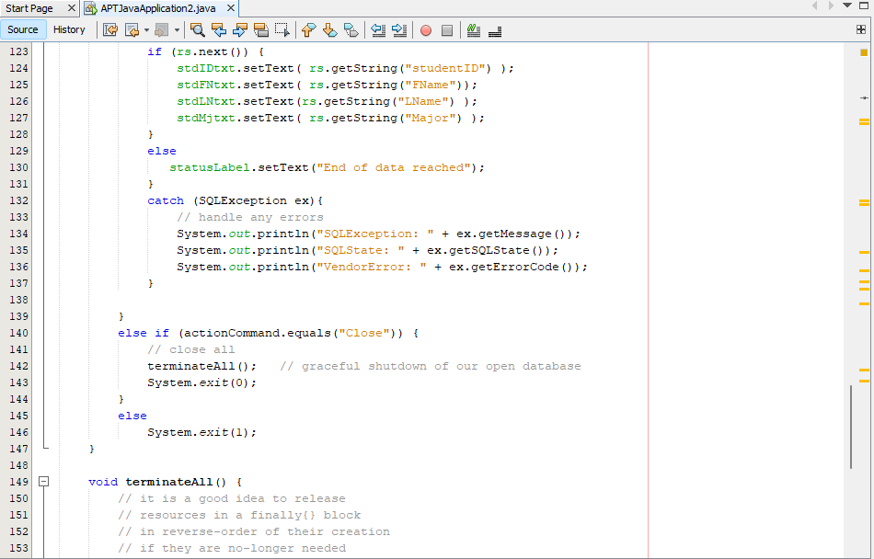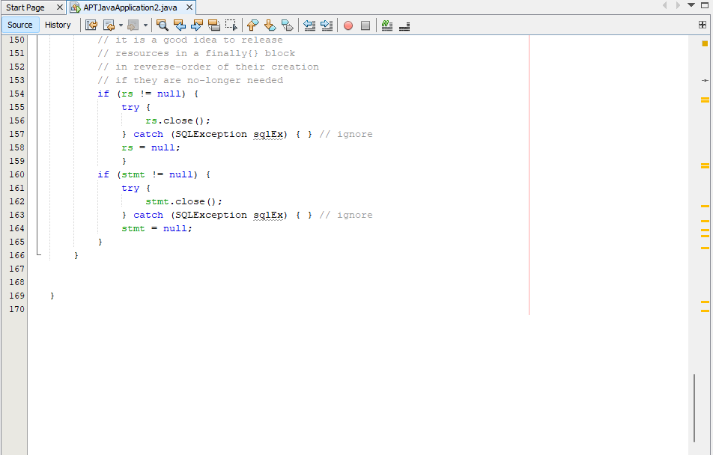

When you run the code

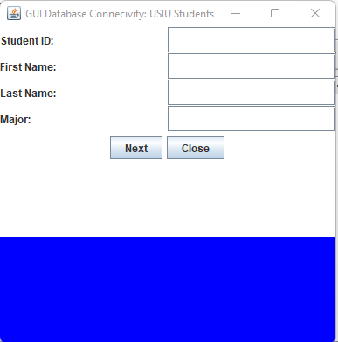

After you click Next button

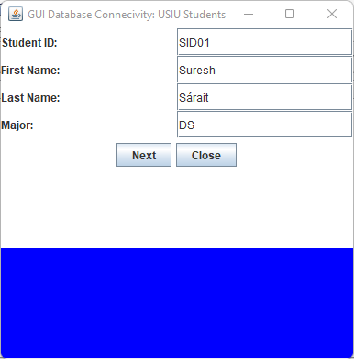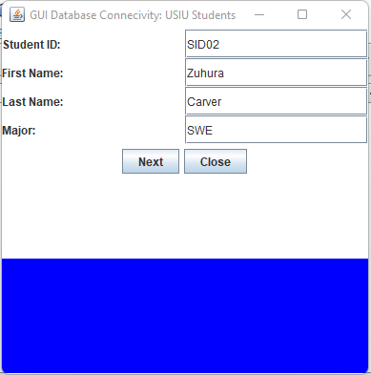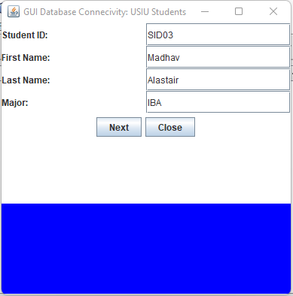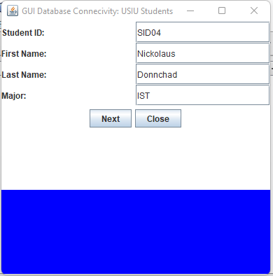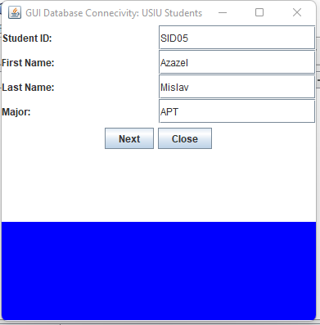

When there is no more data

